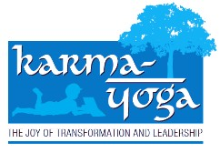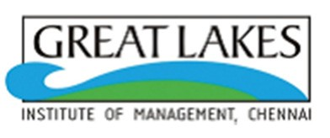

HIGHLIGHTS OF ACTIVITIES OF KARMA YOGA LEADERSHIP EXPERIENTIAL PROJECT DURING JAN-MARCH 2015

Great Lakes Institute of Management (http://greatlakes.edu.in/) became a signatory to the United Nations Global Compact's Principles for Responsible Management Education (PRME) in 2013. This quarterly newsletter is published with the objective of sharing with others the way in which the institute inculcates responsible behavior in students

Dear Colleagues

Greetings from Karma Yoga!

Great Lakes Institute of Management is part of the UN Global Compact and our Karma Yoga Newsletter is published to share the information among the global business schools to promote the importance of responsible management education.
The much awaited Karma Yoga convention was a success as the testimony for the gratifying activities of the students among the village communities. Large number of participation from women and children vindicates our presence among the most vulnerable section of those communities.
Leadership and social responsibility are the essence of karma yoga’s curriculum and are embedded in its ethos. It promotes a sense of awareness and values-based leadership amongst the students with respect to the underprivileged sections of the society.

We are happy to circulate the news of Karma Yoga in updating the role of our Great Lakes Institute of Management in leveraging what we each do best and what we all can do together to support the communities around us.

KY Team

“There is considerable evidence that women’s education and literacy tend to reduce the mortality rates of children”. - Amartya Sen.
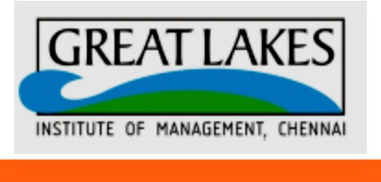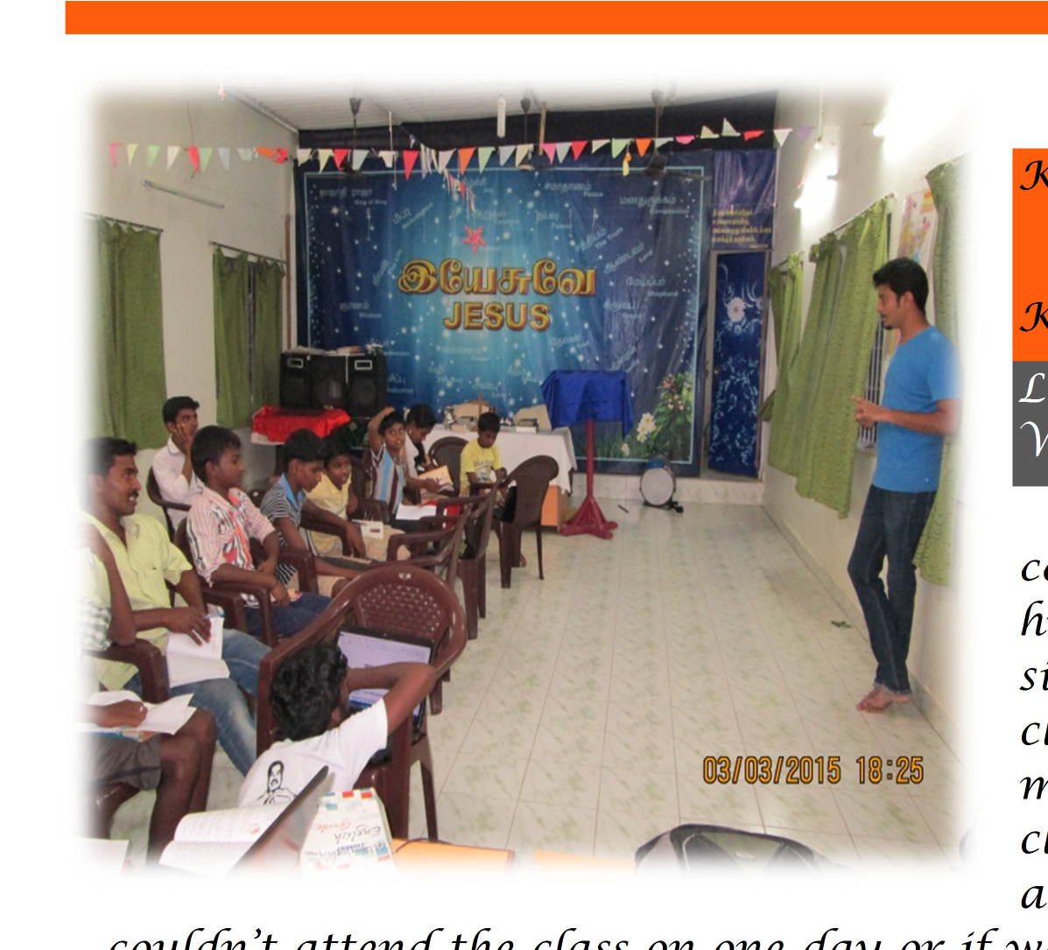
m

a

h
L

K

K

ARMAYOGA – LINGAPURAM…the

Y team speaks…

ingapuram Computer Training
Workshop 2015

We started taking computer classes every Sunday for 1-2 rs. But, this was not enough, because, since we could go only once a week, the classes were there only 4 times a onth. Also, after each class the next class would be after a week, which left huge gap in between. When someone
couldn’t attend the class on one day or if we were not able to go to village on one of the Sundays, there was a huge 2 week gap. The retention was very low. Due to little or no practice, the understanding was not up to the mark. The students lost interest in the class and the turnout became low.
Thus, the idea of 8 days Lingapuram Computer Training workshop was
born.

We decided to focus only on Microsoft Office for this workshop. The three main parts that would be covered were MS Word, MS Excel and MS PowerPoint. The workshop was divided into modules. Each module ranged between 2 to 3 days depending on the complexity. The workshop was held from 2nd March 2015 to 11th March 2015 with 2 unavoidable holidays in between. Even though more than 20 odd students registered for the workshop, we zeroed in on 10 students due to constraints in resources. We had to plan for the entire week as to who will be going to the village on which day. Planning the visit by with members who do not have class along with a backup for unforeseen changes was a huge task in itself. We went to the village in groups of 3-4. We had to make sure there was at least one Tamil speaking member in the team. Regular attendance was taking to make sure everyone takes the class seriously. At the end, certificates were distributed for participants who had attended all the classes. There were 7 participants who go the certificates.

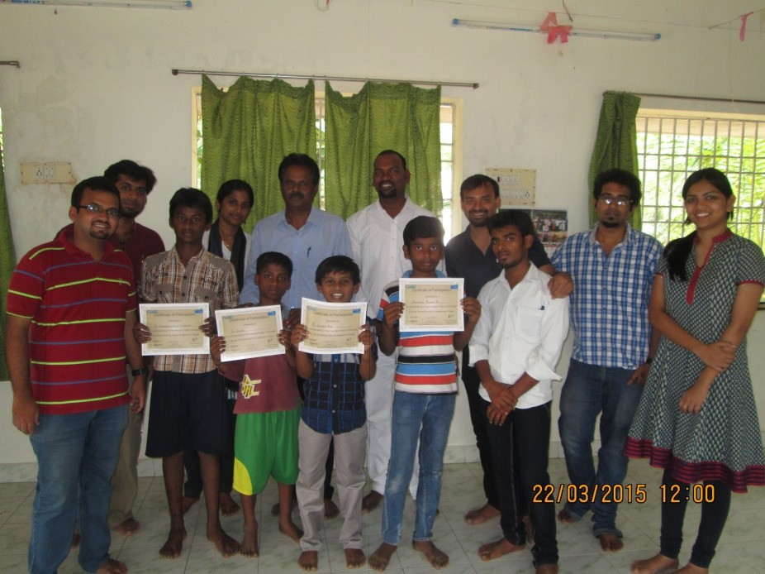The Certificate distribution was held on 22nd March 2015 which also marked the last visit to the village. The certificates were given out by our Arul Samy Addl-General Manager KarmaYoga Leadership Experiential Project. The students were very much motivated and enthusiastic about this initiative. They were quite eager to learn and took notes during the
teaching. The first Computer Training Workshop was tremendously successful and
has been able to generate a kind of curiosity with regards to computers.

Link for Photos:

https://drive.google.com/folderview?id=0B2Dv9VRmib_GfjByemZPS256MTdYdE
NDNjBwMzN0NjVwdG8tUTl3WUNtR080REFxQUViZmc&usp=sharing

Swatch Bharath campaign in Nallur

The KY village teams speak with the
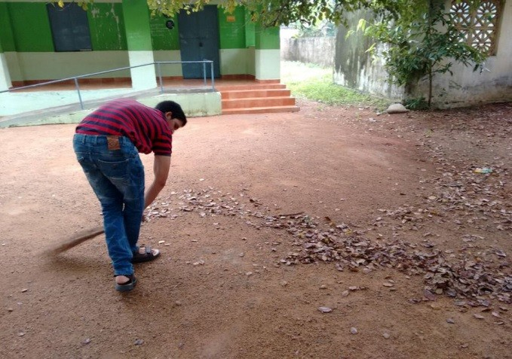concluding note …...

Today was probably our last Karma Yoga visit for this term. We had planned a special event. A video shoot for the official KY video was also planned at our village today Venki and Varun gathered the kids, while the remaining of us started decorating the school for the event. We could find posters from the government regarding cleanliness and hygiene and the need to prevent
diseases. We used this as an opportunity and used this poster to explain to the people

in the colony the need for cleanliness.

To understand power, one must first understand the state of powerlessness". One year of Karma yoga - Leadership experiential program has been a great journey for all of us and has taught us
Many things directly .we completed a full circle as we ended with the same enthusiasm and vigor that we had started with back in May-June when we had our first event. We have indeed worked together as a team in brainstorming on all the ground work and coming up with new and innovative things every week to try and empower the
villagers in whatever possible way we could.

Kollamedu …KY team
We took their feedback on the various activities we conducted in the village throughout the year. Lastly we wish to thank each one of them for the impact they had on us and express our gratitude for their support and co-operation.

This was the 1st year of the many more years of association of GLIM with Kollamedu. We are confident that the next batch will carry on the mantle and continue the
serving the people of Kollamedu.

EYE CAMP….. KY Team
Naduvakkarai….

This week's event saw a huge turn out with over
180+ patients visiting us from Naduvakkarai and near by villages for the general health camp and the eye camp!
The camp was organised in association with Rotary club of Chennai and Udhi Eye Hospital Chennai.
The camp started early at around 9.30 and went on till 1.30pm. The Rotary
club even provided the patients with medicines for some common ailments.

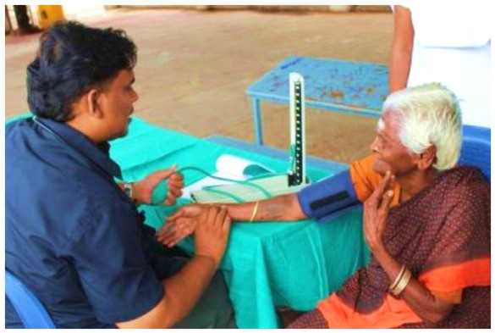
The contingent from Udhi Eye hospital did a thorough job and found around many patients who needed to be operated for cataract. We convinced five people to go
through with the cataract surgery with was being extended to them free of cost. We believe this is a significant step and will definitely have a positive impact on their lives.
The Rotary Club also agreed to distribute glasses to the villagers, who were diagnosed with vision problems, for a subsidized rate.
Over all, this event was a success and the Rotary team appreciated the effort we had put in to organize this event.

Karmayoga.Natham
Kariachei Team….

Last week involved the inception of kitchen gardening at Natham. With the support of Sumati Akka we were able to pick out two plots to start with. The first plot was a piece of barren land behind a villager’s backyard. The plot will be ready for fencing and watering next week. We investing time to help weed out the same.
The second plot which is adjacent to a paddy field had fine alluvial soil which we were able to dig and plant seeds Brinjal. Ladies finger and tomato seeds were planted and watered. The house owners were excited about ladies finger growing in their backyard as it is a local favorite.
Library Infrastructure Inauguration- Lingapuram….

From what started as a shelf with 123 books to a full-fledged Library structure with more than
240 books with seating, Lingapuram Library has come a long way. What we as the Team Lingapuram dreamed of has come true in front of our eyes.
Initially since the number of books were around 120, it was easier to keep them in the shelf which we called the library, but as the number
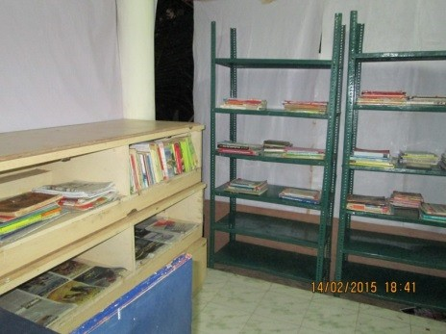
of books that came in increased, it became a lot more difficult to handle the books. The shelf was placed inside the church and hence used up the space. During the morning mass, the shelf was moved to accommodate people inside the church. This moving of the shelf also created lots of problems for the books. Overall, it was becoming an issue to sustain the library. We had to move from the shelf to a much bigger and fixed place.

The infrastructure of the library was arranged by the Pastor and the villagers themselves. Pastor arranged for 2 steel racks for the books. The earlier shelf was also used. The entire portion of the Library was covered with plastic sheet as a safeguard from natural
calamities. An electrical connection was given for the lights and four chairs and a small table were kept for sitting. The Pastor also had a Poly-vinyl flex mentioning the Library and KarmaYoga Great Lakes. The inauguration of the structure was done on
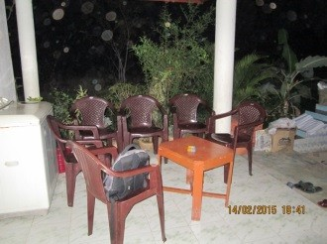14th February 2015. The day being Valentine’s Day, Lingapuram decided to dedicate it to the love of knowledge. As a chief guest, we had Mr. Kumar from Tamil Nadu Science Forum who graced the event. In his speech, he said how impressed he was with the village for taking the initiative and also promised to provide any sort of help needed to develop education in the village. It was a proud moment for Lingapuram as well as for us to be able to achieve this feat. Even though this is a small step in order to help the village develop, we as Team Lingapuram believe that as the future batches come to Lingapuram they would be able to work and develo
p more on
this.

Karma Yoga Convention
1st March 2015

Venue: Annai Theresa
Arts and Science College

The year long association with the villages under KarmYoga – an initiative by the Great Lakes Institute of Management, Chennai culminated in the annual convention on March 1st, 2015 at Annai Theresa Arts and Science College. The agenda was to reflect on what have the students contributed to the villagers so far and how to take the things forward in the upcoming session.

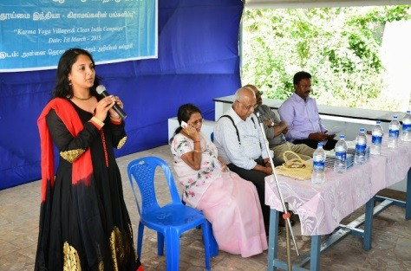

The convention kicked off on a Sunday morning with the welcome message from Prof. Dr. Bala V Balachandran, Founder and Dean, Great Lakes Institute of Management to the gathering followed by speeches by the esteemed guests.

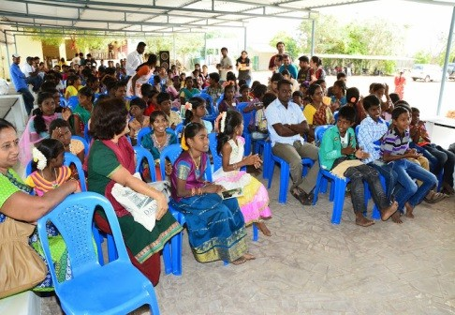

The Guests of Honor included Prof. Bobby Srinivasan, of Finance and Trading and the first year PGDM Director at Great Lakes Institute of Management, Chennai; Prof. Mr. Phelly, a Visiting Professor, Business & IT, Great Lakes Institute of Management, Chennai; Mrs. Kavitha, Additional Commissioner (HRCE) and Mr. Jayavel (Tamil Nadu Science Forum).

Various socially relevant topics were talked about at the convention. Some of these included Organic farming, Kitchen garden and importance of good sanitation. These are also some of the initiatives of students in their respective villages. The speeches were followed by experience sharing by the students and what they have learnt through this experiential learning program.

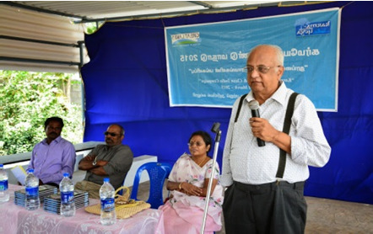

Cultural events were planned for the village kids, which included fancy dress competition, singing and dancing. There were
4-5 teams that
participated in these events.

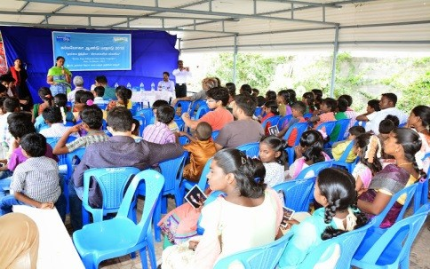
There was enthusiastic participation from the villages under Karma Yoga. There was a big turnout of kids and elders. Some villages had as many as 30-40 kids showing up for the convention. This was an amazing feat and showed the kind of relationships that students of those villages could nurture during their year long stint with them. The whole atmosphere was full of energy and all of the participants – be it the students or the villagers. The convention concluded with the Vote of Thanks to our esteemed guests, followed by the National

Anthem. Then the participants proceeded for lunch.

It is worth mentioning that it was total dedication and earnest efforts of the students of Great Lakes institute of Management, Chennai that made this convention a success. They volunteered for this cause and were working nonstop since early morning – be it visiting the villagers and arranging transportation for the villagers or the organizing of the
convention or the hospitality they showed during the convention.

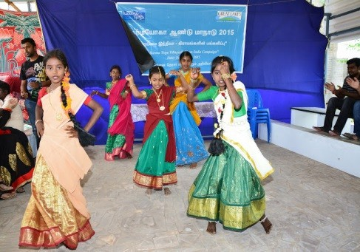

The qualities of true leaders were visible in the students and it suffices to say that KarmaYoga, indeed, has transformed these students for the better.

