Former Executive Director of Great Lakes Institute of Management, Prof. S. Sriram Passes away
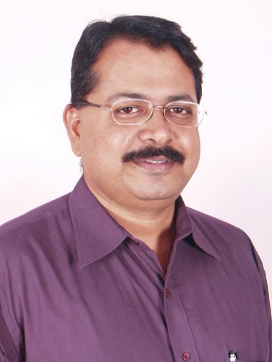
It is with great grief, we inform you the sudden demise of Prof. S.Sriram, Former Executive Director of Great Lakes Institute of Management. Prof. S. Sriram passed away due to cardiac arrest at around 7.30 P.M on Friday, 29.04.2016, at Apollo Hospital ,Teynampet, Chennai.
Prof. S.Sriram was handpicked by Prof Bala V. Balachandran in 2004 during the founding of Great Lakes Institute of Management. Prof S. Sriram assumed the role of Executive Director of Great Lakes Institute of Management since inception and his contributions to the institution is unparalleled. His sudden death has left the institution with great grief and an irreparable loss.
Shocked by his demise , Prof. Bala V. Balachandran stated “Sriram has been at my side ever since Great Lakes had its humble beginnings in 2004 in Saidapet and he has been my lieutenant , my colleague, my confidant, my friend, my companion and most of all he has been like a son to me ! His sudden demise has left me in a state of shock. There is so much more that I want to say, but words fail me. A huge void is what he has left us with - Great Lakes owes a deep debt of gratitude to him and it will be an irreparable loss to me personally - he was a good man – wiser and mature than his years and endowed with great strength of character ! I will always remember our association and the time that we spent together very fondly.”
Sriram’s funeral is scheduled for Sunday, May 1 around 7 am when his mortal remains will be moved from the mortuary of Apollo Hospital to his parents' residence in West Mambalam - Sri Vidhya Apartments, next to Ayodhya Mandapam and cremated once the rituals are completed.

